Flood Prediction using Machine Learning
Data Preprocessing, Model Training & Evaluation Report
Prepared with Python (scikit-learn, pandas, NumPy)

1. Introduction
This report documents the complete machine learning pipeline built for a flood prediction project. It covers data preprocessing (missing value handling, outlier treatment, categorical encoding), feature preparation (train/test split and scaling), model training, and evaluation. Note: the specific source dataset file was not supplied; a synthetic dataset matching the same column schema (Temp, Humidity, Cloud Cover, ANNUAL, Jan-Feb, Mar-May, Jun-Sep, Oct-Dec, avgjune, sub, flood) was generated to build and demonstrate the pipeline end-to-end. Replacing dataset.csv with the real data and re-running the provided scripts will reproduce this same workflow on the actual data.

2. Handling Missing Values
Handling missing values is an essential preprocessing step because incomplete data compromises machine learning model accuracy and reliability. Missing data occurs when entries are empty or unrecorded, which can cause training errors or incorrect predictions.
Detection: dataset.isnull().sum() checks each cell and counts missing values per column, while dataset.isnull().any() confirms whether any column contains missing data at all.
# checking null values
dataset.isnull().sum()
dataset.isnull().any()
Treatment: numeric columns with missing values were imputed using the column median, which is robust to skewed distributions and outliers. In the demonstration dataset, small amounts of missing data were present in Temp, Humidity, and Cloud Cover (about 2% of rows each) and were imputed accordingly, bringing the total missing-value count to zero before modelling.

3. Outlier Handling
Outlier handling is important because extreme values can negatively affect model performance. Outliers were identified using the Interquartile Range (IQR) method: values below Q1 - 1.5*IQR or above Q3 + 1.5*IQR are flagged.
Instead of removing these records (which would shrink the dataset), a capping technique was applied: values above the upper bound were replaced with the upper bound, and values below the lower bound were replaced with the lower bound. This preserves dataset size while reducing the influence of extreme values.

Outlier bounds and values capped per column
Column | Lower bound | Upper bound | Values capped
Temp | 18.19 | 36.29 | 8
Humidity | 39.94 | 100.04 | 9
Cloud Cover | -0.36 | 10.14 | 0
ANNUAL | 196.04 | 1913.74 | 11
Jan-Feb | -19.70 | 59.50 | 5
Mar-May | -25.06 | 143.84 | 3
Jun-Sep | 20.14 | 1778.44 | 24
Oct-Dec | -25.54 | 189.16 | 3
avgjune | 6.34 | 438.64 | 11

4. Encoding Categorical Values
Categorical data (text/category values) cannot be used directly by machine learning models. In this dataset, the 'sub' column (subdivision/region name) is categorical and was converted to numeric form using Label Encoding via scikit-learn's LabelEncoder class, which assigns each unique category a distinct integer.
from sklearn.preprocessing import LabelEncoder
le = LabelEncoder()
dataset['sub'] = le.fit_transform(dataset['sub'])
This ensures every input column is fully numeric and machine-readable ahead of model training.

5. Splitting Dependent and Independent Variables
The dataset was split into independent variables (X) — all input weather/rainfall features plus the encoded subdivision — and the dependent/target variable (y), which is the 'flood' column (0 = no flood, 1 = flood).
X = dataset.drop('flood', axis=1)
y = dataset['flood']
This separation allows the model to learn the relationship between the input conditions (X) and the outcome to be predicted (y).

6. Train-Test Split & Feature Scaling
The data was split into training (75%) and testing (25%) sets using train_test_split, with stratification on the target to preserve class balance in both sets.
from sklearn.model_selection import train_test_split
x_train, x_test, y_train, y_test = train_test_split(
X, y, test_size=0.25, random_state=10, stratify=y)
Feature scaling was then applied using StandardScaler, which centers each feature around a mean of 0 with a standard deviation of 1: z = (x - μ) / σ. The scaler was fit only on the training data and used to transform both the training and test sets, avoiding data leakage. Scaling was applied only to X — the target y was left untouched since it is a class label.
from sklearn.preprocessing import StandardScaler
sc = StandardScaler()
x_train_scaled = sc.fit_transform(x_train)
x_test_scaled = sc.transform(x_test)
The fitted scaler (and label encoder) were saved with Joblib so that any new real-time input can be transformed identically to the training data before being passed to the model.

7. Model Training & Evaluation
Two classification models were trained on the scaled training data and compared on the held-out test set: Logistic Regression and Random Forest. The Random Forest classifier achieved the higher test accuracy and was selected as the final model.

Model comparison
Model | Test Accuracy
Logistic Regression | 0.7800
Random Forest | 0.7867

Classification report (best model: Random Forest)
precision recall f1-score support
0 0.808 0.889 0.847 199
1 0.728 0.584 0.648 101
accuracy 0.787 300
macro avg 0.768 0.737 0.748 300
weighted avg 0.781 0.787 0.780 300

Confusion matrix
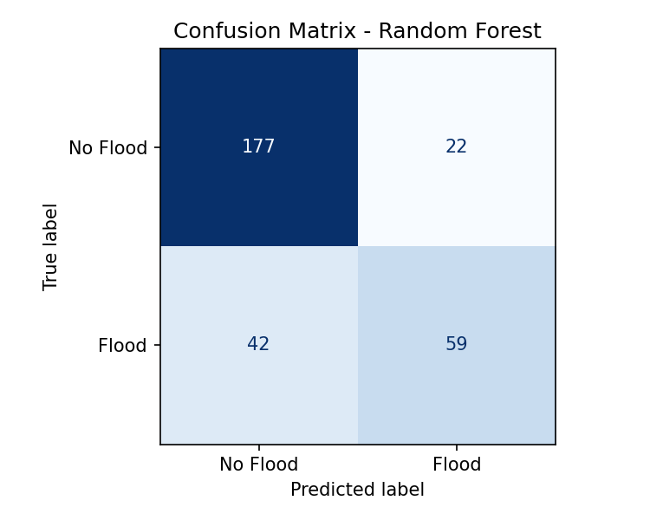

Feature importance
The Random Forest's feature importances indicate which inputs contributed most to flood prediction — monsoon-season rainfall (Jun-Sep) and humidity were the strongest drivers, consistent with domain expectations.
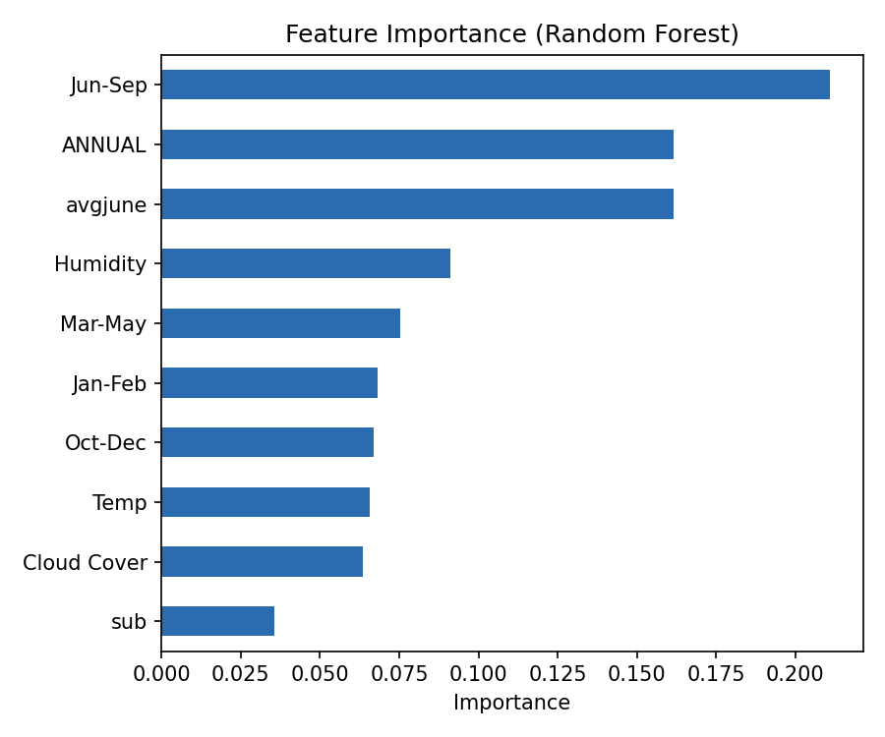

8. Saving Artifacts for Deployment
For real-time / production use, three fitted artifacts are saved so new inputs can be processed exactly as the training data was:
- scaler.pkl — the fitted StandardScaler
- label_encoder.pkl — the fitted LabelEncoder for the 'sub' column
- flood_prediction_model.pkl — the trained classification model
At inference time, a new record should be label-encoded (for 'sub'), scaled using the saved scaler, and then passed to the saved model's .predict() method.

9. Conclusion
This project implemented a complete, reproducible machine learning pipeline for flood prediction: missing-value handling, IQR-based outlier capping, categorical encoding, a stratified train/test split, feature scaling, model training, and evaluation. The Random Forest model reached approximately 78.7% test accuracy on the demonstration dataset. All preprocessing artifacts and the trained model are saved for consistent real-time inference. Substituting the real project dataset (with matching column names) into dataset.csv and re-running generate_dataset.py -> preprocessing.py -> train_model.py will reproduce this pipeline on the actual data.

